SAMPLE MODULAR SKATEPARK NO. 490115
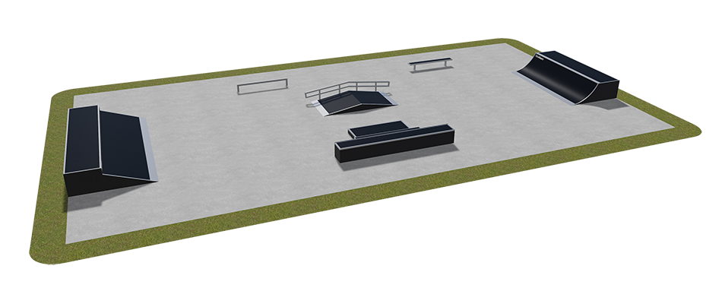

Lp. | Przedmiot dostawy – elementy | Ilość
1 | Quarter pipe | 1
2 | Grindbench 1 | 1
3 | Grindrail profil [] | 1
4 | Funbox + grindrail | 1
5 | Grindbox 2 + Grindbox 1 | 1
6 | Grindbox 12 | 1
Area: 310 m²

For sports:
Skateboard ***
In Line **
BMX *

Available options: skatepark can be made
in options Prestige or Deluxe.

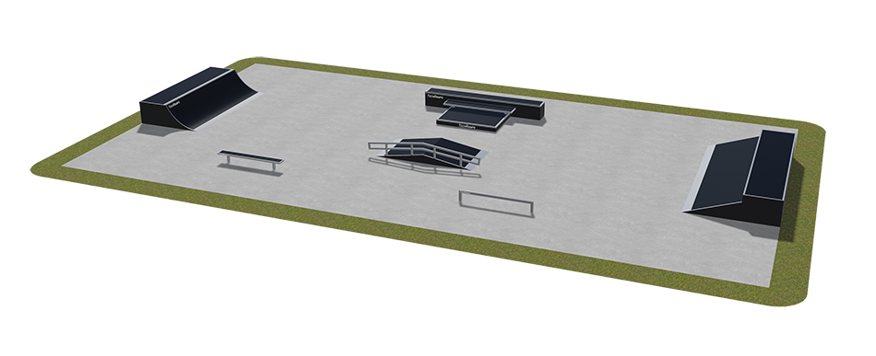

SKATEPARK SPECIFICATION, PRESTIGE OPTION
This specification contains:
- Requirements for materials used in skatepark devices.
- Device structure.
- Riding surface finishing.
- Protective handrails.
- Steel.
- Safety.

- Tolerances.
- Knowledge and experience.
- List of appendices.
- Terms of Warranty in the Prestige option.

I. REQUIREMENTS FOR MATERIALS USED IN SKATEPARK DEVICES
1) SKATEPARK DEVICE STRUCTURE
- Material
- Load-bearing (structural) boards must be made of dark, waterproof plywood, laminated on both sides, minimum 18 mm thick.
- Element modules must have openings of 12 mm in diameter in between particular beams. The openings are used for screwing particular modules together using galvanized M12 screws. External element openings are provided with additional ventilation function. All visible screws must be finished with a round head (appendix 2).
- Particular sections must be reinforced from the inside using 60x90mm beams, mounted

with a minimum 250mm span, as per their central sections, and covered with an impregnant. In rear structures, 80x80mm beams lined with dark, waterproof, laminated plywood are admitted.
- A ventilation system made of HPL boards, 6m thick must be installed on the side boards of external structural panels, 18mm thick in such a way that gravitational air flow is ensured through the entire element (appendix 2).
- All side panels must be supported by insulated stands as to eliminate the absorption of humidity of these elements. Stands of this type will also provide additional ventilation (appendix 2).
- Screws mounted on the sides (of the structure) must be screwed in to level with the lining (before screwing-in, the holes must be drilled and milled on a CNC machine in order to make sure the screw head hides in the lining).
- Structural beams must be screwed to load-bearing boards using steel-zinc-plated 6x140 Torx screws. A minimum of 2 screws must be located at the end of each beam.
- In order to make sure that beams are not pressed out of their place during use, their fixing must be secured by additional supports (inrun support, supporting structure). At least 80% of supporting beams must be additionally reinforced with supporting elements (appendix 3).
- Elements higher than 1m and wider than 1.8m must be equipped with a maintenance-inspection door (appendix 4).

b) Board jointing
- In order to extend a load-bearing (structural) board, the interlocking puzzle-element structure must be applied in order to prevent particular elements from separating under strains and tensions (appendix 1).

b) Foundation layer (layer separating the riding surface from structural squared timber)
- In all arched sections, the foundation layer is made of dark, waterproof plywood, laminated on both sides, at lest 9mm thick (a 10mm thick version out of Polyethylene is admitted) and is screwed in to the structure using steel-zinc-plated 50x60 or 6x60 Torx screws.
- In all straight sections, the foundation layer is made of dark, waterproof plywood, laminated on both sides, at lest 18mm thick (a 12mm thick version out of Polyethylene is admitted) and is screwed in to the structure using steel-zinc-plated 50x60 or 6x60 Torx screws.
d) Quality and repeatability warranty
In order to increase the precision of finishing and repeatability of elements, all external and internal load-bearing (structural) boards must be cut using dedicated CNC* machines.
* Computerized Numerical Control (CNC).

2) RIDING SURFACE FINISHING
- The riding surface must unconditionally be finished with a 6mm professional RampLine mat (a HPL variety with anti-slippery surface) screwed-in using steel-zinc-plated 6x60 Spax or Torx screws.
- 90% of all holes for screws must be drilled and milled to fit screw heads. Hole treatment must be made using a CNC machine.
- 90% of all edges of the RampLine mat must be milled using a CNC machine (appendix 5).
- All screw heads must be sunken in the outer layer of the riding surface finishing up to maximally 1 mm (screw heads must not protrude from the board surface).
- Due to the thermal elongation factor of materials or the unevenness of groundwork, on which the element is standing, board joints may feature minor apertures. In this case, all such places must be sealed with sealing-adhesive mass (appendix 5).
- Due to the specification of their use, such elements as grindbox must be additionally secured on all sides of the riding surface with 6mm thick RampLine mat. This rule may be abandoned only when one of the sides (due to the location of the grindbox) is not used (appendix 6).

3) PROTECTIVE HANDRAILS
All 1m high or higher devices must be equipped with protective handrails along the back and sides of the platform (this condition does not apply to tall jumping funboxes, in which the installation of handrails may lead to raising the risk of accidents).
- Handrails must have vertical crossbeams in order to prevent anyone from climbing on them.
- The height of protective handrails above the platform must be at least 1.2m.
- The external frame of handrails must be made of galvanized steel, out of 30x30mm profiles and Ø16mm pipes, with spans observing the provisions of the effective PN-EN 14974 standard, as amended.
- Front and rear handrails must be screwed-in together using screws with metric threads.
- Handrails must be mounted to the ramps using SW 17ø10x90 hexagonal wood screws (appendix 7).

4) STEEL
Handrails and other steel elements must be made of zinc-plated steel.
Coping must be made of a zinc-plated steel pipe of 48 to 60.3 mm in diameter.
Coping must be mounted to the platforms using steel-zinc-plated 6x60 Spax or Torx screws. Pipe endings must be capped with steel end-caps in order to prevent anyone from hurting themselves (appendix 8).
When it comes to grindboxes, coping may consist in 50x30x2mm steel profiles.
On platforms, where coping is installed, additional sheet metal layers, 3 mm thick and 120mm wide must be installed along the coping in order to secure the riding surface against mechanical damages (appendix 8).

All angle irons must be rounded on bends (cold-rolled steel), plus their endings must be rounded as well.
Sliding rails must be mounted on 6mm sheet metal of 60x300mm and must be screwed-in to the foundation using 6x60 Spax or Torx screws.
ll holes and openings in sheet metal must be drilled and milled to hide the screw heads after screwing-in.
All inrun sheet metal layers must be 350÷400mm wide and 3mm thick. In addition, they must be mounted to structural elements using steel-zinc-plated 6x40 or 6x60 Spax screws and must rest on a minimum 60mm structure.
The groundwork for sheet metal must be milled. Sheet metal must adjoin the foundation layer in order to create a smooth riding surface (appendix 9).
In corners and edges of pyramids, metal thresholds must create smooth passages.
All exposed edges of the RampLine mat must be secured with galvanized steel angle irons, 3mm thick and 30÷50mm wide. The angle irons must be mounted along the central line every 250mm using 4x60 or 6x60 Spax or Torx screws. On arched elements, angle irons must be rolled – appendix 10 (cutting angle irons or applying flat bars is unacceptable).
Upper fitting on the shorter sides of grindboxes must be always leveled with the board surface. If the grindbox is wider than 60cm, then the longer angle iron must be also leveled with the board surface. In other cases, it may be mounted on the board. The fitting must be made of an angle iron of min. 50x50mm and of at least 3mm in wall thickness (appendix 11).

5) SAFETY
- An instruction manual on the use of the skatepark must be always posted in a visible place at the entrance to the skatepark (appendix 12).
- The selection of elements and their distribution, maintaining the requirements of safety zones, as well as full observance of instructions on use minimizes the risk of injury during use.
- All works must be carried out in compliance with effective regulations and under the supervision of licensed personnel.
- All materials used must hold the obligatory certificates, technical approvals, declarations of conformity, etc. and must be used in accordance with their technical sheets provided by their manufacturers.
- All devices designed for sports, play or recreational purposes as well as communal devices installed within the facilities included in the scope of this study must unconditionally observe all safety requirements specified in effective standards (PN-EN 14974+A1:2010 Facilities for users of roller sports equipment. Safety requirements and test methods).
In order to maintain quality, it is required that the ordering party encloses a control chart for the facility (appendix 13)
II. TOLERANCES
- All protruding edges must be galvanized. Copings may protrude up to 12mm above the surface level.
- Any radiuses must not deviate more than 20mm from the specified dimension.
- Horizontal holes and openings in boards must be performed in min. 450mm spans.

- The spaces of holes and openings on the edges of board sheets must be performed in min. 250mm spans.
- All holes and openings near adjoining edges must be performed symmetrically.
- The overall dimensions of devices may differ by 6%, depending on the angles applied.

III. KNOWLEDGE AND EXPERIENCE
In investments of this type (a skatepark is a facility characterized by greater risk of injury) it is essential that the proper quality of finishing is ensured, which may only be obtained by cooperating with companies which have performed similar facilities in the past. Potential contractors must hold applicable experience in constructing skateparks (including i. a. Techramps, Concrete skateparks, Altramps, etc.), since a skatepark is a specific facility – it is not a typical playground or a sports field. The experience of a contractor must therefore be certified in the form of references, thanks to which the Ordering Party will be sure that they contract the construction of their skatepark to the right company.
Ordering Party requirements:
- The Contractor will prove that they have performed min. 5 construction works basing on constructing a plywood-composite skatepark of the value of works of PLN 300 thousand gross each within the period of five years before the deadline for submitting offers, and if the period of activity is shorter – then in this period. Each offer should specify the date and place of each of the listed construction investments and should enclose documents certifying that the works were carried out properly and in accordance with the principles of construction.
- All wooden-composite devices installed in the skatepark must hold applicable TÜV certificates, which means that they must hold a Conformity Mark** to guarantee that the product and its manufacture process are tested and supervised by an independent Certifying Body. The certifying body must be accredited by the Polish Center for Accreditation (PCA).** This mark and the related certificate confirm the properties of products, which provides an additional guarantee of their safety and highest quality, as proven by compliance with the PN-EN 14974:2007 + A1:2010 standard.
- Due to the characteristics of skateparks as facilities, the foreman of the assembly team must have proven experience in constructing facilities of this type, as certified by documents confirming the performance of at least 10 similar skateparks within the last 5 years.

