SAMPLE CONCRETE SKATEPARK NO. 545857
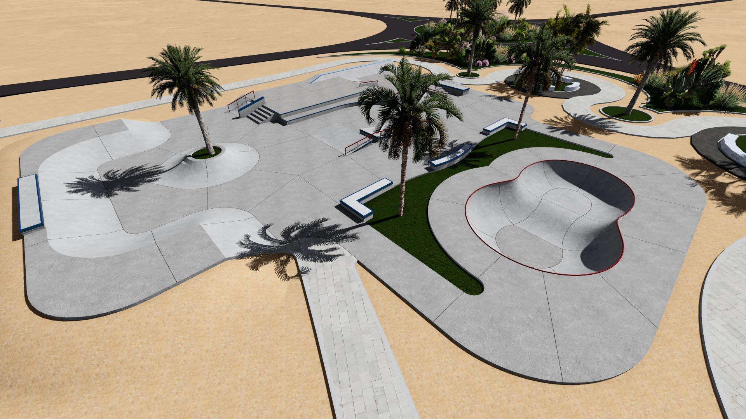

Area: 1010 m²

For sports:
Skateboard ***
InLine **
BMX **

Options: Skatepark will be build in monolithic concrete technology or in Light Concrete technology.

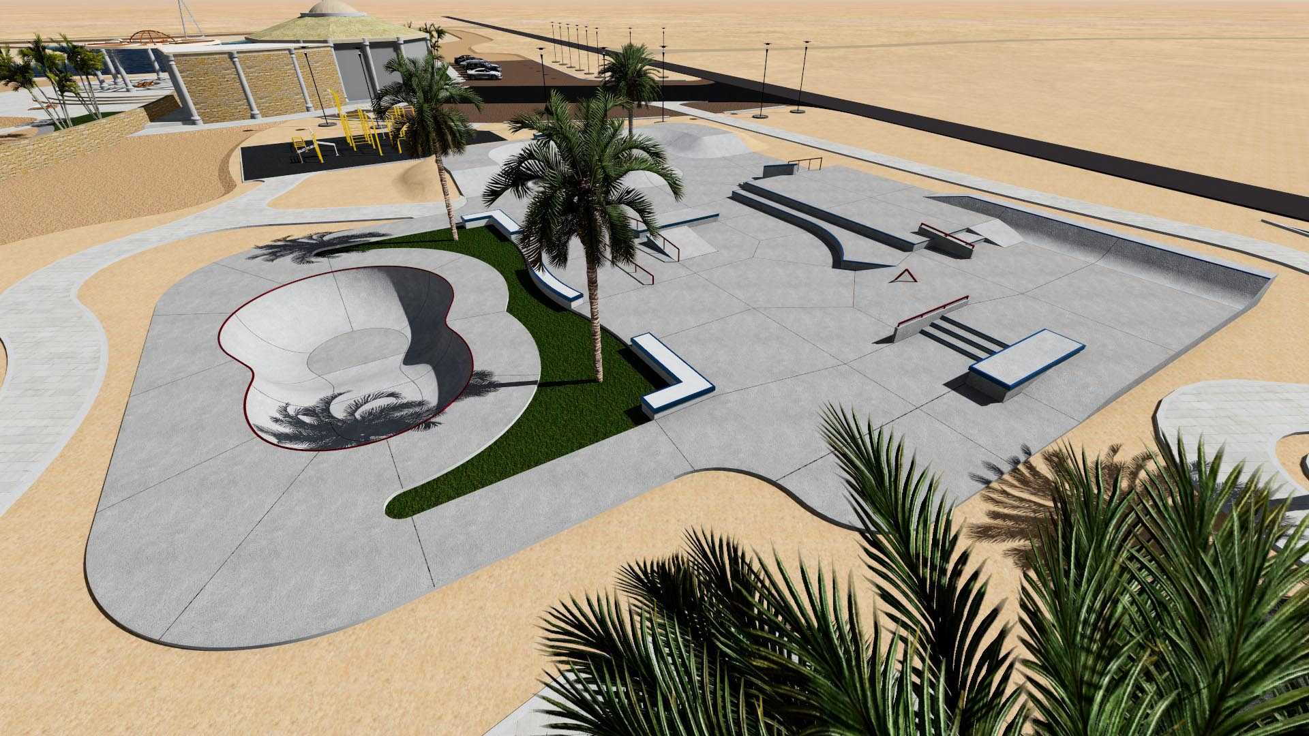

Abbreviated specification of concrete option
1) Skatepark elements.
Obstacles are designed in reinforcement concrete form, or as slabs or walls and are reinforced with ∅ 8 mm mesh (AIIIN) with 15x15cm stitches. Concrete - C30/37, W-8, F150.
All curved elements have to be made with shotcrete technology (on wet). Concrete is layered with spray method and recipe mix is used to do it.
All templates, shutterings and welts for curved elements must be produced on CNC machines in purpose to achieve the least declensions from target dimensions of elements.
2) Main slab
Concrete surface is made as an industrial floor and is minimum 15cm thick. It is made from C20/25 concrete which is hydrotechnical (W8) and resistant for freeze (F150). The surface is reinforced from the bottom with ∅ 8 mm mesh (AIIIN) with 15x15cm stitches.
In the slab should be made expansion gaps with expansion field dimensions. Max 5m x 5m on the depth of 1/3 slab thickness.
The slab must have pitches in range from 1 - 1,5%. The pitches should be one-sided if skatepark geometry allows for it.

The surface should be: flat, soft and resistant for impacts (skateboarders and skates who have wheels with 44-59mm diameter cannot feel any irregularities on the surface)
It is not allowed to paint the main slab surface, and the riding surface on the elements because it will be dangerous for skatepark users. The surface covered with paint become very slippery and increases risk of fall and injury. The paint can only be on the sides of the elements.
3) Subgrade
Under the skatepark slab and elements made form concrete on the ground.
-Subgrade from crushed-stone aggregate with fraction 0-31,5m - thickness 15cm
- Subgrade from crushed-stone aggregate with fraction 31,5-63,0mm - thickness 15cm
4) Steel
All steel elements such as rails, barriers and fittings must be made from hot-dip galvanized steel.
- Copings have to be made from steel pipe with 38-60,3mm diameter. The pipe endings have to be blinded with steel plugs to avert cuts.
- All profiles and angle irons have to have metal spinned edges (cold-rolled steel)
- Elements such as safety profiles, copings or rails have to be embed and anchored in element on which they are placed.
- Safety profiles on elements have to have minimum dimension equal 40x40x4mm (on stairs - 30x30x3mm).
- Profiles on elements such as grindboxes or concrete benches have to be placed coequally to upper surface of the element.
- Steel rails and benches should be anchored to slab directly to her rebar. It should be done before the slab inundation.
Safety barriers
Every element which has more than 1m height must have safety barriers. Barriers should be placed on the sides of a dais and in its back. (It does not concern high funboxes for jumps) The height of safety barriers should have at least 1,2m above dais.

Safety
- Skatepark instruction manual should be placed in visible place, near skatepark's entrance.
- Choice of elements and their correspondingly with safety areas placement and statute adherence decrease the risk of injury.
- All works have to be done in accordance to standing rules and have to be supervised by qualified people.
- All used materials must have required certificates, technical approvals, declarations of conformity and so on. They also should be applied in accordance to their technical cards given by producers.
- All sport, entertainment, recreational or municipal devices placed in area covered with this elaboration, have to absolutely fulfil all requirements in terms of safety use in accordance to standing norms: PN-EN 14974+A1:2010 - Devices for users of skate equipment. Requirements for safety and methods of testing.
II. Tolerance
a) All radii cannot change more than 20mm from definited dimension.
b) The dimensions of the elements may vary by 6% depending on the angles.
Purchaser requirements:
1. Before the deadline of submitting offers, contractor will prove that in period of last 5 years, has built at least 8 concrete monolithic skateparks. Total cost of work of each skatepark is not less than 400 000 PLN gross. The date and place of the work execution must be given, and also documents are required, which prove that the work was done properly and pursuant to construction rules.
2. The constructor will prove, that have at one's disposal a piston concrete pump with working pressure from 68 bar to 76 bar and with productivity from 16m3/h (minimum) to 31 m3/h (maximum). The constructor will also prove that he/she has shotcrete equipment and a worker who is qualified to operate it.
3. The constructor will prove that he/she has PCA (Polish Centre of Accreditation) certificates for skatepark elements (for example: COBRABiD, TÜV and so on). Technical decisions given by associations or experts are not allowed because they are not qualified to give certifications proving product standard.

4. The constructor will prove that he/she has at least 2 workers who has worked in construction of minimum 10 monolithic concrete skateparks. Worker's curriculum vitae is required and it should include a description of an investment, what function the worker had during the construction and worker's signature.

